Biophore’s carbon footprint

Here we present Biophore's carbon footprint to the best of our knowledge. We recognize that the data presented in this document is incomplete, and sometimes biased towards DMF, as its authors are affiliated with that department and they could more easily collect data internally. If, while reading, you identify opportunities to collect similar data for other departments, please let us know. We hope that the gaps in the data will serve as an incentive for improved data collection in the future.

# Table of contents

* Methods
  + The UNIL donut as a framework to measure Biophore’s carbon footprint
  + Top-down and bottom-up approaches to measure Biophore’s carbon footprint
* Results
  + Overview of top-down estimate of Biophore’s carbon footprint
  + The Biophore community
  + Energy (Electricity, Heating and Cooling)
  + Spaces
  + Aviation
  + Resources for research: computational
  + Resources for research: laboratory equipment, consumables and outsourced services
  + Beyond Biophore’s direct influence: food
  + Beyond Biophore’s direct influence: commuting

# Methods

## The UNIL donut as a framework to measure Biophore’s carbon footprint

We use the UNIL donut model as a framework to assess Biophore's environmental impact. This model includes several dimensions, such as greenhouse gas (GHG) emissions and biodiversity. UNIL’s impact on each of these dimensions is categorized into key areas: food, buildings, mobility, and consumables. The UNIL donut was calculated for both 2019 and 2023 (links to UNIL donut [2019](https://serval.unil.ch/resource/serval:BIB_50ACBD5B0BC5.P001/REF.pdf) and [2023](https://www.unil.ch/files/live/sites/unil/files/02-universite/0205-transition-ecologique/Donut/Donut_2023_VF.pdf)); in Fig. 1 and 2 we show the results for the impact on GHG and biodiversity, respectively, in 2023. The largest contribution to GHG emissions is due to Professional Mobility, which is almost entirely due to aviation (Fig. 1). The relative impact on biodiversity (Fig. 2) is similar for several areas, with a few striking differences: aviation has a lower relative impact on biodiversity, but commuting to work, especially by car, is responsible for about a third of the total impact. IT hardware is also a noteworthy example of an area that has a relatively small impact on GHG, but a very significant impact on biodiversity.

Fig. 3 compares GHG emissions from the two assessments, and shows an overall reduction in GHG emissions in 2023 compared to 2019. This improvement occurred despite an increase in construction materials and can be attributed to a decrease in meals purchased from the cafeterias (though this likely means that more people bought their food outside of UNIL), a reduction in air travel, and fewer purchases of laboratory equipment.

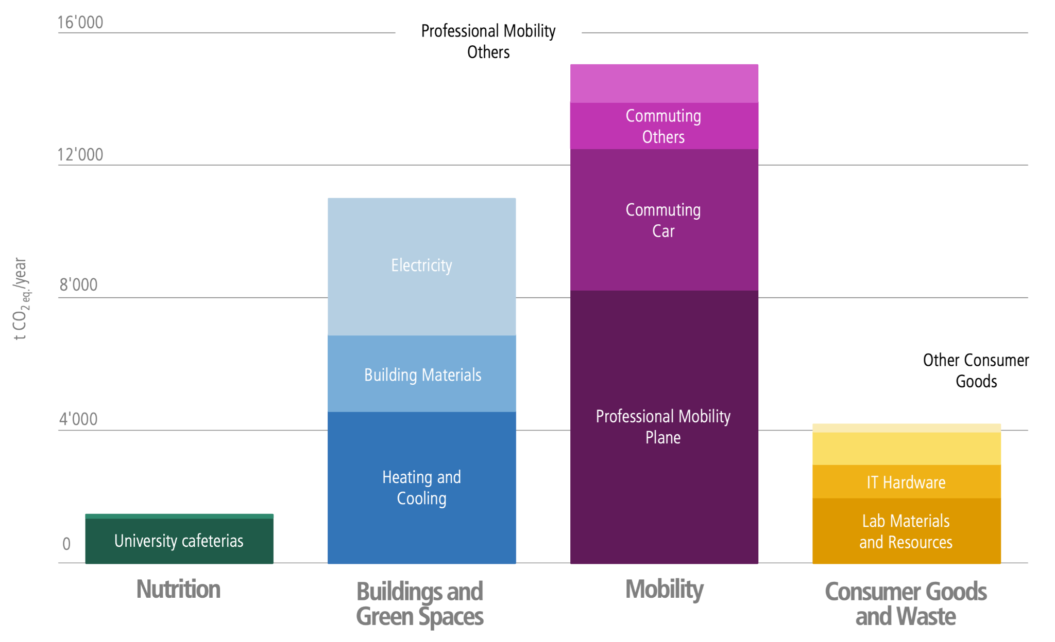

**Fig. 1 UNIL donut 2023: impact on greenhouse gas emissions** measured in units of tons of equivalent CO2 per year (t CO2e/year). Courtesy of Cecilia Matasci (CCD).

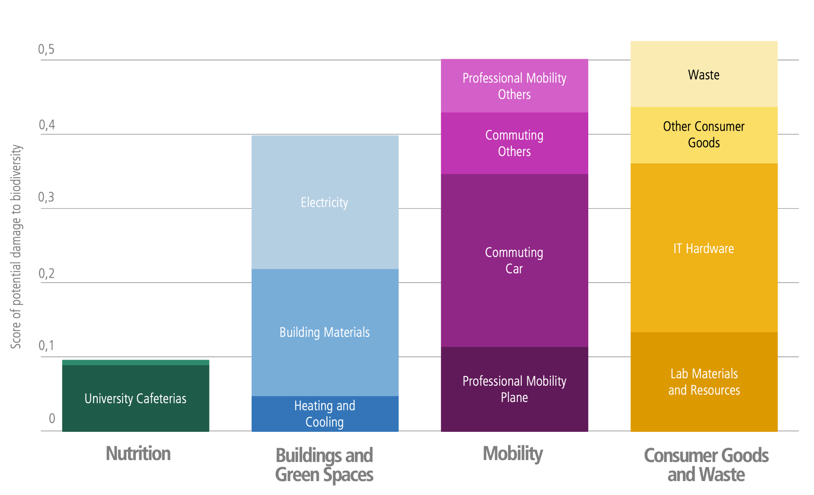

**Fig. 2 UNIL donut 2023: impact on biodiversity**. Courtesy of Cecilia Matasci (CCD).

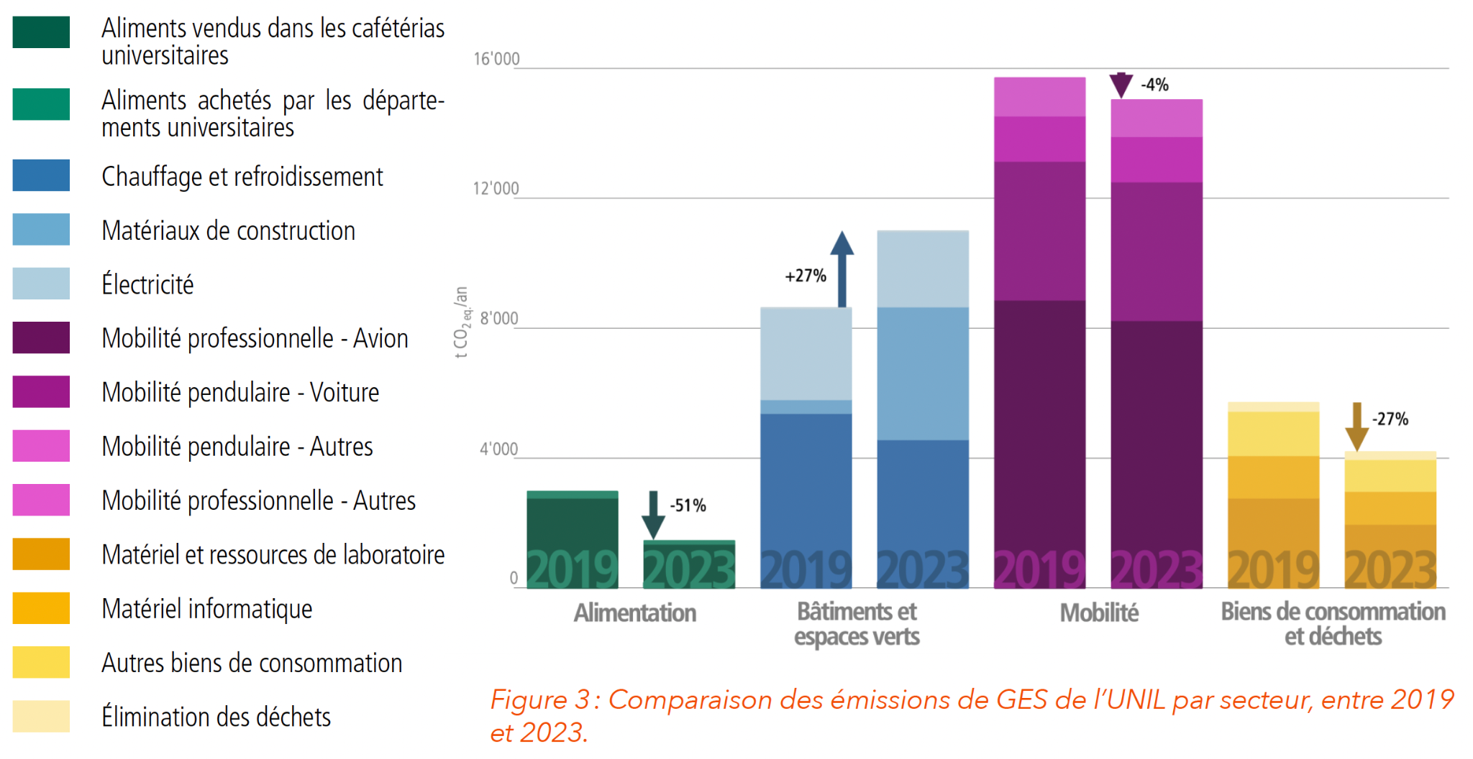

**Fig. 3 Comparison between UNIL donut 2019 and 2023: impact on greenhouse gas emissions**. Courtesy of Cecilia Matasci (CCD).

## Top-down and bottom-up approaches to measure Biophore’s carbon footprint

Using the UNIL donut framework as a template, Cecilia Matasci (CCD) conducted a **top-down** assessment of Biophore’s carbon footprint by disaggregating UNIL-level data to the Biophore level. In parallel, Greener Biophore organizers and other Biophore employees (mentioned in the acknowledgements) performed a **bottom-up** analysis using data available within the three departments. While the top-down approach was the most comprehensive of all areas affecting GHG emissions, the bottom-up approach allowed finer resolution and deeper insight into several of those areas.

For simplicity, we focused our analyses primarily on GHG emissions, although we believe it is important to keep in mind the high impact on biodiversity of commuting and IT Hardware. Not all categories considered in the UNIL donut are directly applicable to the Biophore context. In our Biophore-specific analysis, we exclude the “Food” and the “Commuting” categories, as they fall outside Biophore’s direct domain of influence and are rather connected with personal choices. Nevertheless, food purchased for events held within Biophore—such as seminars or PhD defenses— do partially fall under Biophore’s influence. We still include an analysis of food and commuting related impact in dedicated sections “Beyond Biophore’s direct influence: food” and “Beyond Biophore’s direct influence: commuting” as they can support personal reflection.

We include electricity, heating, and cooling in our assessment, but we exclude construction materials. Our analysis covers energy consumption within the building, the greenhouses, the computational cluster and the datacenter (see sections “**Energy (Electricity, Heating and Cooling)**” and “**Resources for research: computational**”). While construction materials are excluded, we do assess the use of space, since optimizing available space can reduce the need for new buildings and can lower energy demands for lighting, heating, and cooling (see section “**Spaces**”).

In terms of mobility, we focus exclusively on professional travel, with a special focus on aviation, which is the primary contributor at the UNIL level (see section “**Aviation**”).

We assess the impact of research-related consumables, including plastics, chemicals, IT materials, and laboratory equipment, as well as the environmental footprint of outsourced services (see sections “**Resources for research: laboratory equipment, consumables and outsourced services**” and “Resources for research: computational”). Other types of consumables, such as office furniture or stationary, are not considered due to their relatively minor impact at the UNIL level, which we assume to be similar at Biophore. Likewise, we do not provide a detailed analysis of waste, as it also has a minor impact at the UNIL level. However, given the presence of laboratory waste, it is possible that Biophore’s waste impact is proportionally higher than the UNIL average, and further data would be valuable in this regard.

# Results

In this section we discuss an overview of the top-down estimate of Biophore’s footprint, provide some numbers for the Biophore community and then delve deeper into the results of the data analysis for the chosen areas of impact: energy, spaces, aviation, computational and experimental resources for research, food and commuting. For each area of impact we also report the relevant CAP2037 objectives ([link to CAP2037 strategy](https://wp.unil.ch/cap2037/en/)).

## Overview of top-down estimate of Biophore’s carbon footprint

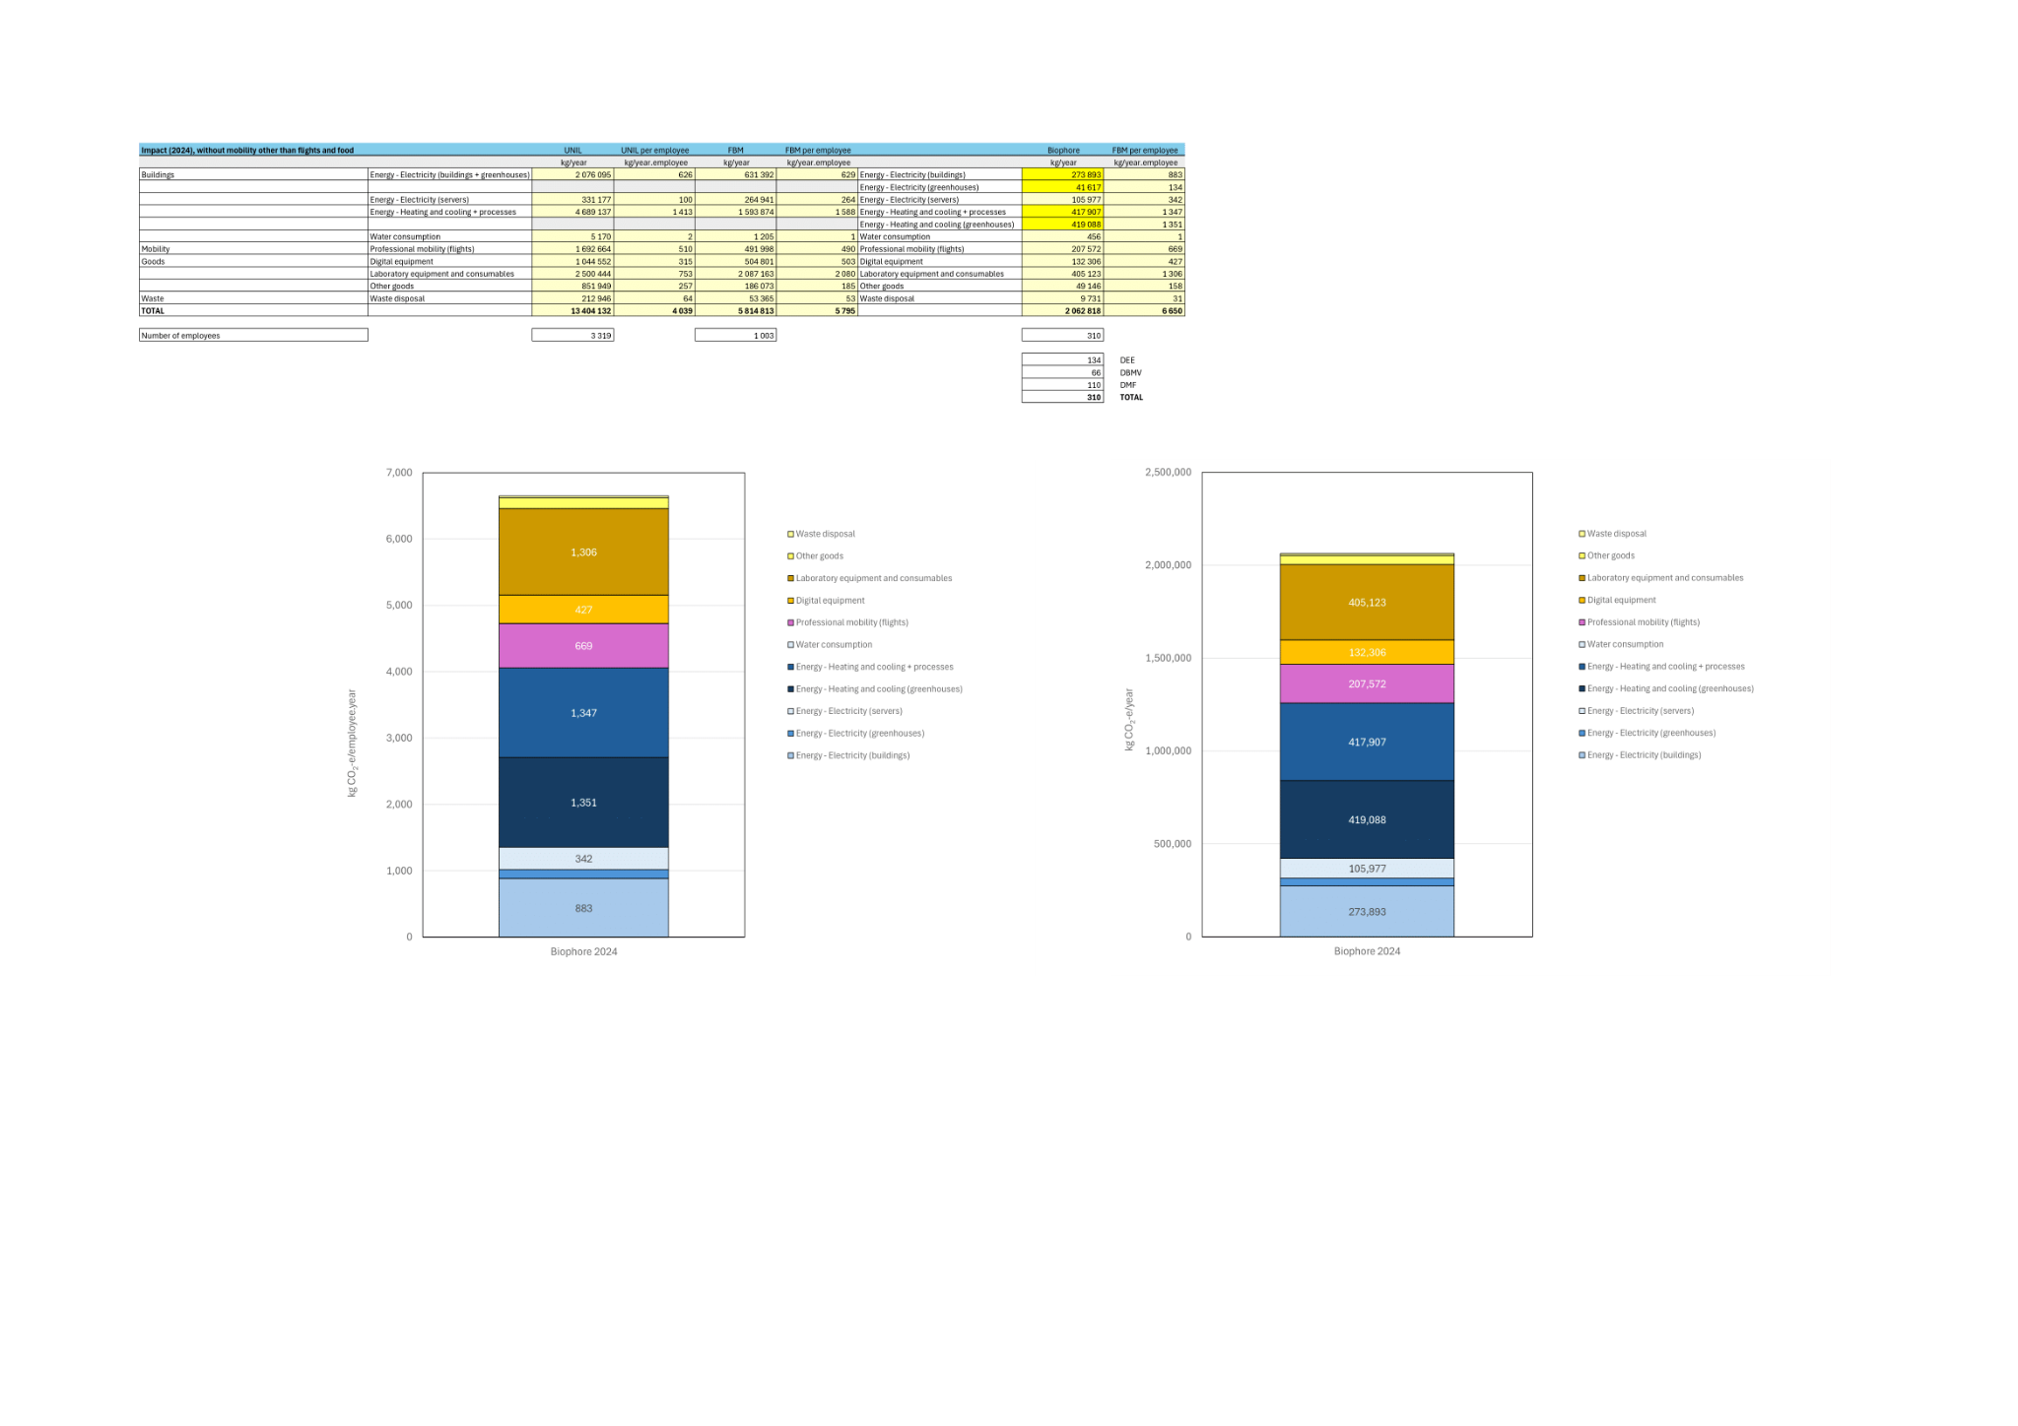

**Fig. 4 Top-down estimate of Biophore’s greenhouse gas emissions in 2024.** Total emissions: 2’062’818 kg CO2eq = 2’062 t CO2eq. Courtesy of Cecilia Matasci (CCD)

In 2024 Biophore emitted 2062 tCO2eq (Fig. 4). The largest amount of this impact is due to infrastructure, about 20% being due to heating and cooling of buildings, and about another 20% to heating and cooling of greenhouses. Another 20% is due to laboratory equipment, followed by electricity for buildings (13%) professional mobility (10%), digital equipment (6%) and electricity for servers (5%).

The impact of aviation is surprisingly low compared to the relative impact of aviation at the UNIL level (Fig. 1). This discrepancy might be due to the different methodologies used for the two estimates: at UNIL-level, the total purchases linked to flights were used to assess flights taken by its employees, while at Biophore-level, the reimbursement forms were used. In the second methodology, some flights might be missed, and this needs further investigation.

The energy consumption due to server use does not include cluster computation (which is done using servers at EPFL) but only data storage at the UNIL datacenters. As we discuss in more detail in section “Resource for research: computational” the energy use for servers is about 10 times higher than the energy used for computation.

## The Biophore community

The Biophore building hosts three departments: DEE, DBMV and DMF. From the website of the departments, we find that the number of people affiliated to the departments in 2025 are

* DBMV 81
* DEE 158
* DMF 130
* total 369

Weighing people by their employment percentage, the number of people becomes, for 2024 (data kindly provided to us by Cecilia Matasci, CCD)

* DBMV 66.1
* DEE 133,8
* DMF 110,4
* total 310.3

Both definitions are used in the following document.

The community is composed of Professors (referred to as PIs in this document), Postdocs and PhD students, and PAT employees (Staff, Technicians, Admin). The impact of students is usually excluded from the analysis in this document, unless stated otherwise. In some figures, Postdocs, PHD students and PAT are grouped together and collectively referred to as PAT.

## Energy (Electricity, Heating and Cooling)

Energy, including Electricity, Heating and Cooling, represented more than half of Biophore’s impact on greenhouse gas emissions in 2024 (Fig. 4). Here we decompose the impact of Energy into its contributions, expressing Electricity in kWh as well as stating the impact on the weight of CO2eq emissions. We convert kWh to grams of CO2eq using the value 128 g CO2eq/kWh, which is the value used for the UNIL donut 2019*.

It is important to note that Biophore is currently heated by natural gas and fuel. UNIL recently built a heat pump system, which will be put into operation in 2027, and will use the lake water to heat all buildings on the Dorigny campus. This will largely or entirely abolish the emissions associated with heating.

From the Biophore donut we read:

* Electricity
  + Biophore building: 883 kg CO2e/person/year = 273 t CO2e/year
    - This value is consistent with the electricity consumption measured from the “Alimentation Générale” electric meter in Biophore, which measured a consumption of 2.2 MkWh/year equivalent to 282 t CO2e/year
  + Greenhouses: 134 kg CO2eq/person/year = 42 t CO2e/year
* Heating and cooling
  + Heating + cooling + processes: 1347kg CO2e/person/year = 417 t t CO2e/year
  + Heating + cooling (greenhouses): 1352kg CO2e/person/year = 418 t CO2e/year
* Servers
  + Data storage: 342 kg CO2e/person/year = 106 t CO2e/year
  + For cluster computing see “Resources for research: computational”

The values associated with energy usage in the Biophore donut 2024 were made available to Cecilia Matasci by Unibat. We independently collected data on the Electricity use of the Biophore building. This value can be directly obtained from the “Alimentation Générale” electric meter.

Fig. 5 shows the time course of electricity consumption from 2010 to 2025. The time between 2015 and 2023 shows a clear decrease in total electricity consumption. Although we were not able to determine the exact causes of the decrease in electricity consumption at every time point, we identified several factors that contributed to this decrease. In 2015 the project “Mission Biophore” was launched: the aim of this project was to identify ways to reduce energy consumption by changing and optimizing practices. This might have stimulated a trend in awareness which continued in the following years, such as increasing the temperature of freezers from -80°C to -70°C (see “Implemented measures for the reduction of energy consumption (Biophore level)”). The Ostral plan which was enforced in 2022, after the Russian invasion of Ukraine, as a measure to save energy, caused a drastic decrease in electricity consumption.The last two years, however, show a new increase in electricity demand. For a more detailed list of measures that decreased electricity consumption over the last 10 years, see “Implemented measures for the reduction of energy consumption (Biophore level)”.

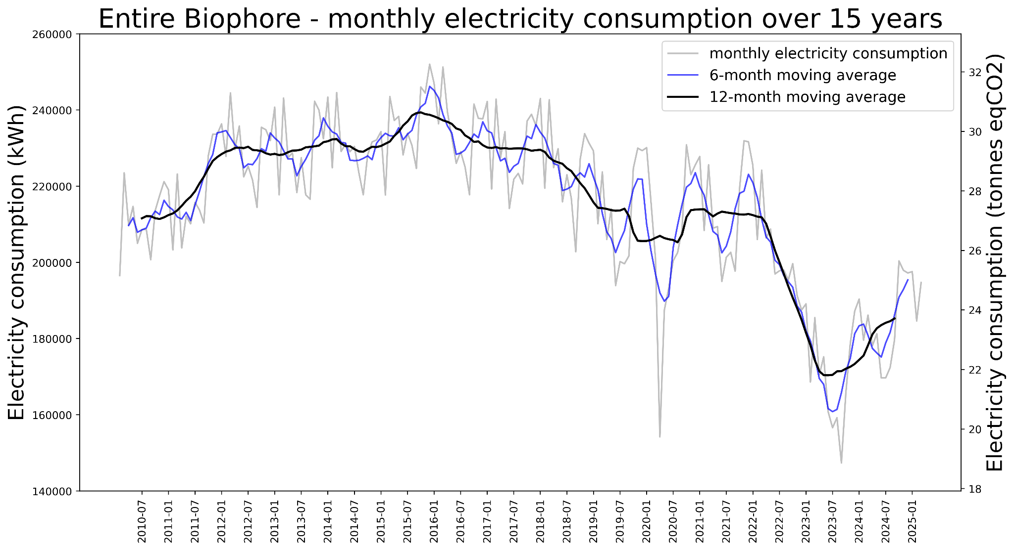

**Fig. 5 Monthly electricity consumption of the Biophore building, from July 2010 to January 2025.**

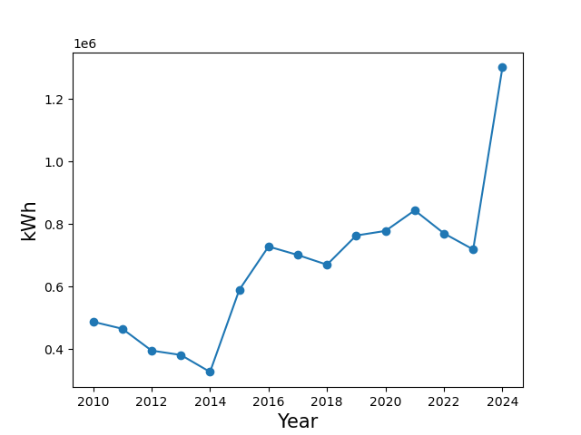

**Fig. 6 Energy consumption for heating of greenhouses.** *Note that it is unclear whether this is the electric part of heating, or whether it is the total energy. In the latter case, the conversion factor must be more than 128 g CO2eq / kWh to match the values in the Biophore donut.*

*This value comes from the [KBOB](https://www.kbob.admin.ch/fr) and considers the average Swiss energetic mix. The value for 2023 is actually 125gCO2eq/kWh.

### Implemented measures for the reduction of energy consumption (Biophore level)

* Mission Biophore (2015): participatory project aimed at reducing energy consumption focusing only on behavioural changes (e.g. correct management of heating and cooling, optimization of equipment usage…) and not on technical changes (e.g., thermal insulation, change of equipment…)
* Replacement of neon lights with LED lights (still ongoing), including the lights of the “salles de culture”
* Ostral plan (2022): optimization of equipment and sharing
* DEE and DMF: increasing temperature of -80°C freezers to -70°C
  + energy saved: 30%
* DEE: switching off unused instruments, replacing most inefficient appliances, increasing temperature of freezers/fridges
  + during the first 3 months of 2023 DEE saved 17% of electricity compared to 2022 (data by Anne-Lyse Roulin and all members of DEE)
* DMF: sharing incubators between labs
* DMF: watt-meter to measure consumption of different machines, to prioritize the use of the more efficient ones

The relevant CAP2037 objectives for this section are:

* Reduce energy consumption related to building usage by 50%, compared to 2019.
* Reduce energy consumption related to research by 20%, compared to 2019.

**Further details on Electricity consumption**

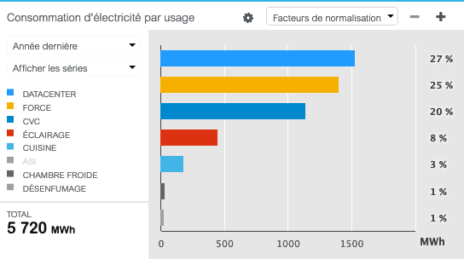

**Fig. 7 Electricity consumption in the Géopolis building in 2022, per category.** Legend: DATACENTER=data center, FORCE= everything that is plugged in the power grid, CVC=ventilation, ECLAIRAGE=illumination, CUISINE=kitchens of canteens, ASI=battery to store energy in Geopolis, CHAMBRE FROIDE=cold rooms, DESENFUMAGE=system to remove smoke in case of fire.   
Note: This plot was made with the old Unibat server. Unfortunately, the software now changed and it is no longer possible to produce such plots. Also, the exact year of this plot might be wrong, and we don’t have ways of checking whether this plot is real.

We do not have the data on the individual factors contributing to the Electricity consumption of the Biophore building. However, this data is available at the Géopolis level. Fig. 7 shows how Electricity consumption at Géopolis level is impacted by different categories of use.

We can also look at electricity consumption of the most energy requiring laboratory appliances

* autoclave 992 kWh/year (assuming 2h per day) *Courtesy of Cecilia Matasci*
* ultra low freezers
  + between 3000 and 6000 kWh/year *Note: from Anne-Lyse’s presentation*
    - Note that vertical and chest freezers can have different efficiencies, but also that vertical freezers heat up more quickly when opened.
* climatic chambers 3300-5700 kWh/year *Note: from Anne-Lyse’s presentation*
* It would be worth looking into consumption of:
  + salles de culture
  + cold rooms
  + ventilation of laboratories and animal facilities

## Spaces

To accommodate an increasing community, UNIL has two options: either building new structures, or optimizing the usage of existing ones. In this sense, avoiding building new spaces prevents carbon emissions (see comparison between Unil donut 2019 and 2023). Moreover, inefficient use of spaces leads to inefficient use of electricity, heating and cooling

In DMF, spaces are mainly allocated to Laboratories (54.7%) and secondly to Offices (32.8%), as shown in Fig. 8 (data elaborated from [planète Unil](https://planete.unil.ch/), the planimetry of UNIL buildings).

In DMF, the per-capita surface area is 24 m². This value has been obtained by considering the total surface occupied by DMF in Biophore, as well as in Ephemere, and the surfaces of areas common to the whole Biophore (the Biophore hall and the Amphitheater). The purely DMF spaces have been divided by the number of DMF employees (110.4) while common areas have been divided by the total number of Biophore employees (310).

The per-capita office space is much smaller than the overall per-capita surface. Considering that 28 PAT employees and 2 PIs are in Ephemere and that the remaining PAT and PIs are in Biophore, we calculated that the per-capita office space is 5m² in Biophore and 6m² in Ephemere (but it is 17m² for PIs).

The per-capita laboratory space is 18m².

The relevant CAP2037 objectives for this section are:

* Reduce the available surface per person by 20% compared to 2019

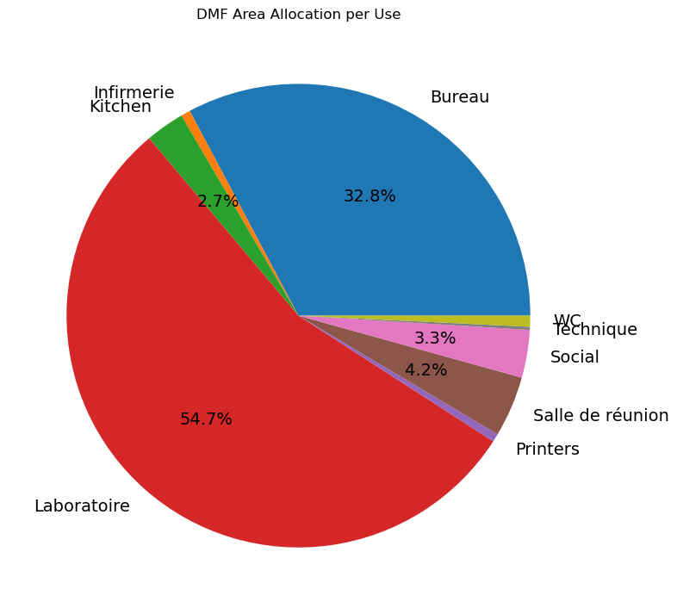

**Fig. 8** Allocation of spaces in DMF.

## Aviation

Data on Aviation for DEE was collected by the DEE travel commission, which estimated 134 tCO2e in 2024 (data provided by Caleb Beck, DEE). Note that there are huge variations since it was 64 tCO2e in 2023 (Fig. 9).

The estimate for DMF for 2023 is 58 tCO2e for 2024 (data provided by Emanuele Boni, DMF). The list of 2023 trips for the DMF was kindly extracted from Valeria Teixeira (DMF secretary) from reimbursement forms. All trips were considered to be round trips, starting from Lausanne. For each trip, the geodesic distance was computed, and the distance covered by train and car was adjusted to consider a small detour factor (x1.2 and x1.3, respectively). Finally, equivalent CO2 emissions were calculated as the product between the distance and emission factors taken from a recent publication on the impact of professional mobility in Academia ([Ben-Ari et al., 2024](https://iopscience.iop.org/article/10.1088/1748-9326/ad30a6/pdf)). The results for DMF are reported in Fig. 9, 10 and 11.

To our knowledge there is no direct assessment for DBMV.

Cecilia Matasci and the CCD estimated the total impact of aviation for Biophore to be 249 tCO2e for 2024. The data collection is based on the online platform introduced with the new Directive on professional mobility implemented in 2024, which requires employees to fill in an online form with the trip details in order to be reimbursed. This methodology probably underestimates the number of flights, since some flights are not reimbursed by Unil (e.g., other funding sources, invitation to speak from other Universities, students’ field trips, trips paid personally)

The data on aviation for Biophore are surprisingly low compared to UNIL data: 806 kg CO2eq/person for Biophore compared to 2410 kg CO2eq/person for UNIL. The reason behind this discrepancy could rely on different methodologies used for Biophore and Unil level estimates, and is currently under investigation.

The relevant CAP2037 objectives for this section are:

* Reduce CO2e due to flights by 60% compared to 2019

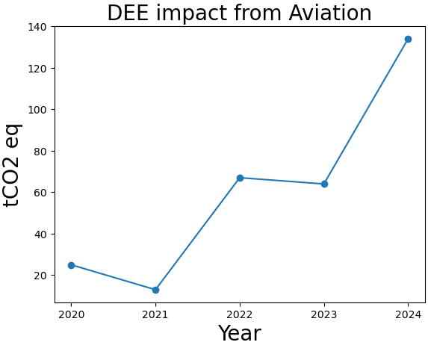

**Fig. 9** **DEE impact on greenhouse gas emissions from professional aviation from 2020 to 2024.** Data provided by Caleb Beck (DEE).

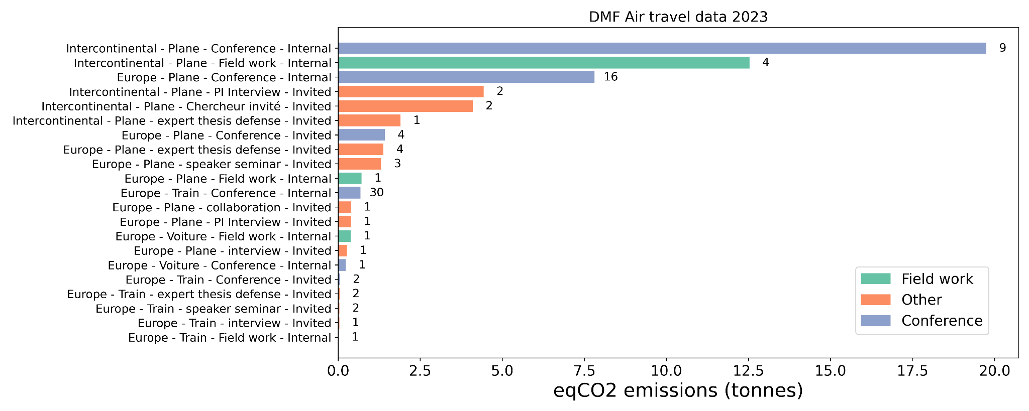

**Fig. 10 DMF impact on greenhouse gas emissions from professional aviation in 2023.**

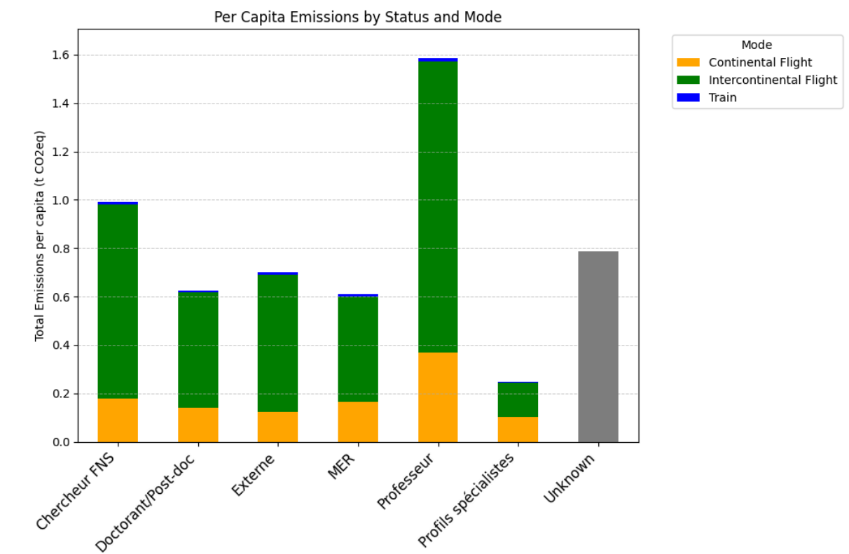

**Fig. 11 UNIL per-capita greenhouse gas emissions from professional travel by status and mode.**

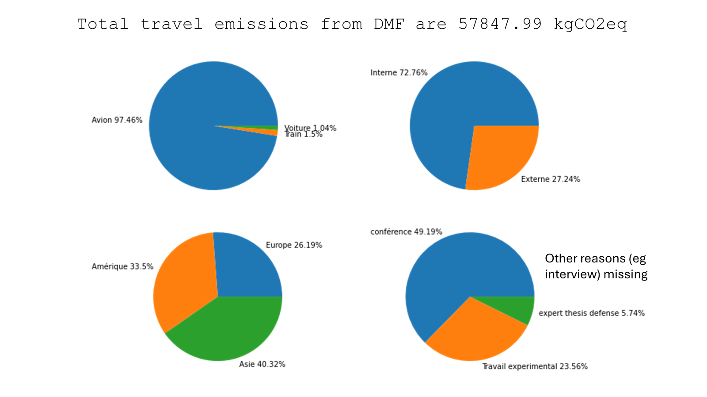

**Fig. 12 DMF impact on greenhouse gas emissions from professional travel in 2023.**

### Implemented measures for the reduction of Aviation use (Unil level)

Professional flights within Europe for which the destination can be reached by different means in less than 10 hours are not reimbursed by the University. See the [directive on professional mobility](https://www.unil.ch/unil/fr/home/profils/collaborateurs-collaboratrices/formulaire-rh/voyages-professionnels.html).

The following plot, provided to us by Nicholas Cheseaux, HEC, shows the cumulative emissions from all professional trips at Unil, as a function of distance and color-coded by type of transport. One of the key take-home messages is that the new Directive only tackles emissions associated with continental flights for which the trip by other means of transport would take less than 10 hours (red color). However, the impact on CO2 emissions of these trips is relatively small compared to intercontinental flights, even if these are a much smaller share of all trips

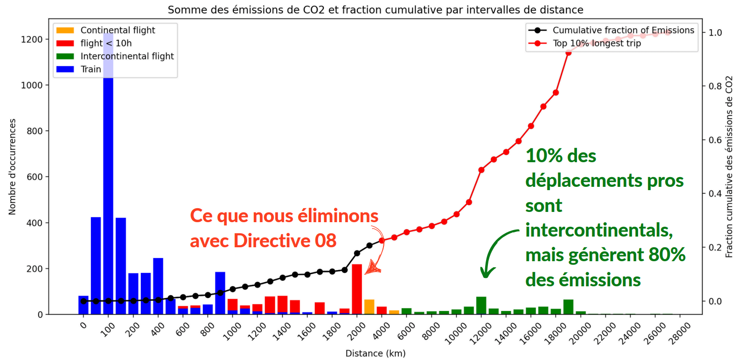

**Fig. 13** **UNIL cumulative fraction of total greenhouse gas emissions from professional travel, ordered by distance traveled and colored by means of transportation.** Courtesy of Nicholas Cheseaux, HEC.

## Resources for research: computational

In this section we consider the impact of energy used to run simulations on the cluster and to store data ,as well as the impact of digital equipment (computers, screens, etc.) As mentioned in section “Energy, Electricity” electricity consumption of UNIL datacenters for Biophore accounts for 342 kg/person/year = 106 t CO2e/year. In the top-down assessment the impact of running the cluster (located at EPFL) is missing, and we report an estimate for that impact in this section.

The following plot breaks down the carbon footprint of computation at UNIL level, into all of its components.

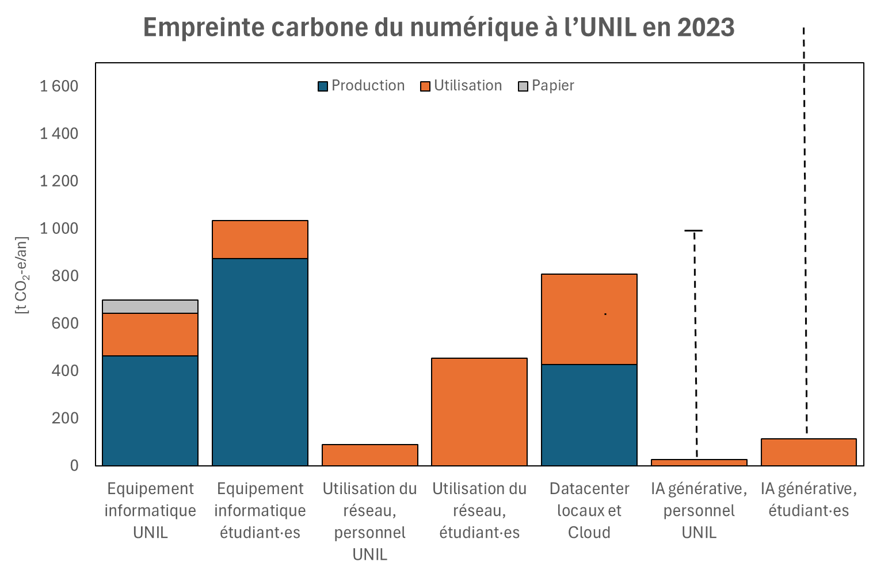

**Fig. 14** **UNIL carbon emissions of digital technologies in 2023.** More accurate estimates for each category are underway. Courtesy of Johann Recordon, CCD.

At Biophore level, Axel Janssen (DMF) and Florent Mazel (DMF) investigated the CO2 emissions associated with cluster computing (more precisely, on the server Curnagl) in DMF, thanks to the [Green Algorithms](https://www.green-algorithms.org/) script that the DSCR installed on the cluster. The total impact of computing was estimated to be 4 t CO2e in 2024 (Fig. 15). The reason why this value is lower than the estimate of the Biophore donut is that the latter takes into account also the impact of data storage.

Fig. 15 shows how the emissions are divided by department and by project.

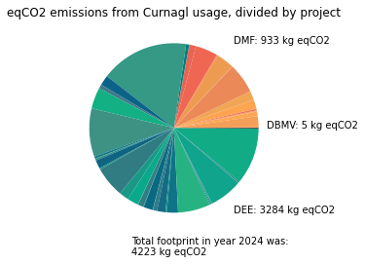

**Fig. 15** **Biophore greenhouse gas emissions from Curnagl usage in 2024, divided by project and department.** Data provided by Axel Janssen and Florent Mazel.

The impact of informatic material in Biophore, estimated from the list of purchases by Cecilia Matasci, CCD, is 132 tCO2eq/year. Among the purchases in 2024 we can note:

* number personal computers bought in 2024: 61
* number desktops bought in 2024: 8
* number of screens bought in 2024: 22

The impact of digital equipment, broken down into categories, is illustrated in Fig. 16.

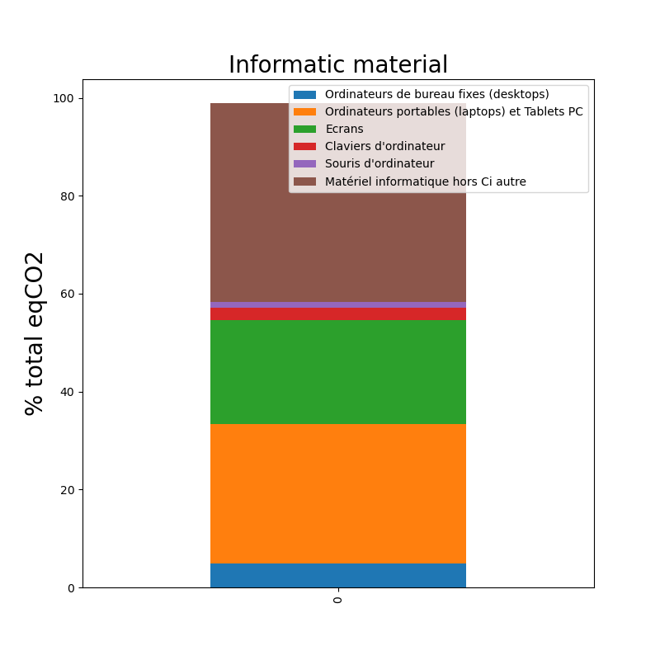

**Fig. 16 Biophore greenhouse gas emissions due to purchased informatic material in 2024.**

The relevant CAP2037 objectives for this section are:

* Reduce energy consumption related to research by 20%, compared to 2019.
* Reduce volume of purchased informatic equipment by 40%, compared to 2019.

### Implemented measures for the reduction of computational resources (Biophore level)

In their analysis, Axel Janssen (DMF) and Florent Mazel (DMF) identified some aspects that can be improved from the user side and provided some guidelines on how to reduce emissions associated with over-requested memory and failed jobs.

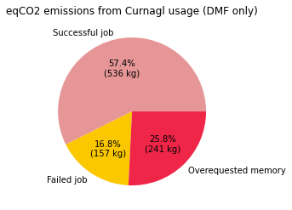

**Fig. 17 DMF greenhouse gas emissions from Curnagl use in 2024.** Data provided by Axel Janssen and Florent Mazel.

### Further details on Generative AI consumption

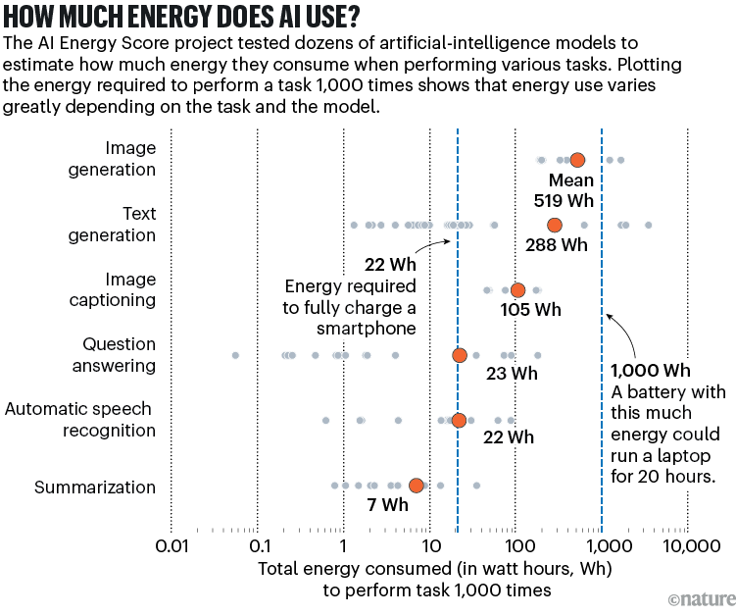

**Fig. 18 Energy consumed by AI per type of request.** [Nature News 5 March 2025 by Sophia Chen.](https://www.nature.com/articles/d41586-025-00616-z)

## Resources for research: laboratory equipment, consumables and outsourced services

Laboratory equipment (machines, microscopes, etc.) and consumables (plastics, chemicals, etc.) together have an impact of 405 tCO2e per year, according to Cecilia Matasci at CCD. This impact is due to the production, assembly and transport of equipment, and not to its use (which is taken into account in section “1 Energy (Electricity, Heating and Cooling”) nor its disposal. CCD calculates this footprint by converting the amount, in CHF, of purchases into an estimated number of items using provider list prices, and then calculating CO2e emissions using estimates for the Life Cycle Assessment of those items. Because UNIL often procures supplies in bulk at discounted rates, however, this approach likely underestimates the true impact.

Figure 19 illustrates the impact of laboratory equipment and consumables, divided into categories. The largest fraction is in the category “Other consumables” that corresponds to orders for which it was not possible to track the content. The second largest fraction is plastic (26%, equivalent to 105 t CO2eq) then Chemicals (17%, equivalent to 69 t CO2eq) and Machines (9%, 36 t CO2eq).

In DMF there is also a bottom-up estimate of plastic use and its impact on CO2eq emissions. The department has put in place a direct estimate of plastic use by tracking orders from the Biophore Magasin. The total weight of plastic used in DMF was converted to CO2eq using conversion factors provided to us by Cecilia Matasci, CCD. The estimate for the impact using this methodology is 16tCO2eq/year. It is worth noting that the weight has not been measured for each item, but for representative items of categories of items, which leads to a source of uncertainty on the estimate, which is nevertheless relatively consistent with the one of CCD.

In DMF there has also been an attempt to track all other purchased items. The software used for the record of all purchases did not allow exporting the data to Excel. However, thanks to the collaboration of Valeria Teixeira, DMF it was eventually possible to do so. The sheet is now available for analysis and could be used to compare results with CCD.

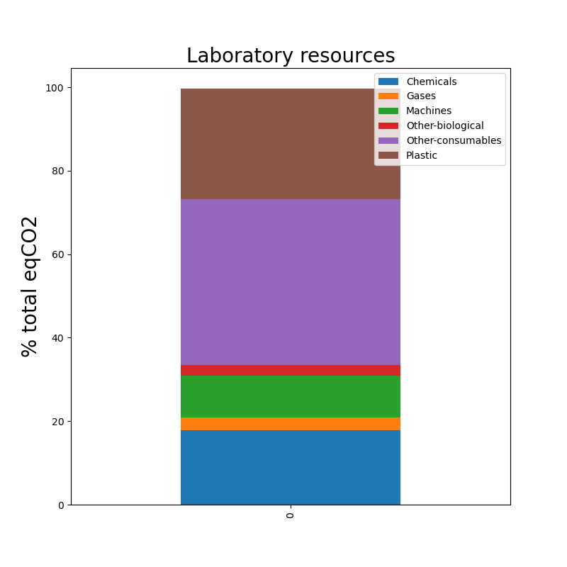

**Fig. 19** **Biophore CO2eq emissions due to laboratory consumables and resources in 2024.** These emissions refer to the production, assembly and transport of items. Data was kindly provided to us by Cecilia Matasci, CCD and elaborated by us.

In 2023-2024, an inventory of all the laboratory equipment present in Biophore, together with an estimate of its average usage time, was compiled by a group of students. It is important to note that the average usage time of most items can vary heavily depending on the period. Also, some items (e.g. freezers) were constantly off while others were constantly off, thereby the average usage time is not really representative of the actual usage.

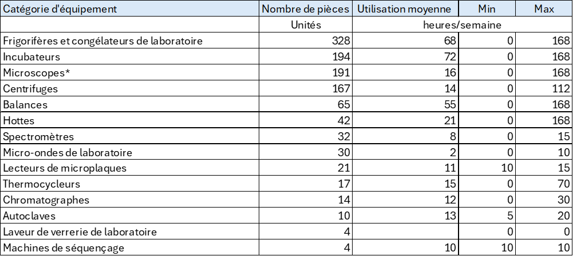

Source : Travail d’inventaire fait par les étudiant.es avec Paul Majcherczyk 2023 -2024

To better capture equipment-related emissions, we also performed an in-house assessment based on the list of instruments available on the DMF website.

We estimated the number of items from:

* the list of incubators, fridges and freezers realized from Louise Martin for the DMF task force.
* the list of equipment available on the FBM calendar for the DMF department
* a small list of the most common molecular biology laboratory equipment (PCR machines, small and big benchtop centrifuges)

We prompted chatGPT to estimate the inbuilt carbon (only production + disposal, no electricity usage) for the list of items, asking for a more and a less conservative estimate. We then divided the total CO2 emissions by the number of years each item lasts for, taking 5 years as a lower limit and 20 years as a higher limit. The [cumulative yearly emissions](https://docs.google.com/spreadsheets/d/1AJsuetKvt-rdbD8ObugXt7JFY9fRwLEz/edit?usp=drive_link&ouid=113338705661737510324&rtpof=true&sd=true) from the items in our list are between 25 and 250 tonnes CO2eq. The order of magnitude matches with the top-down estimate based on purchases, which is around 400 tonnes for the entire Biophore.

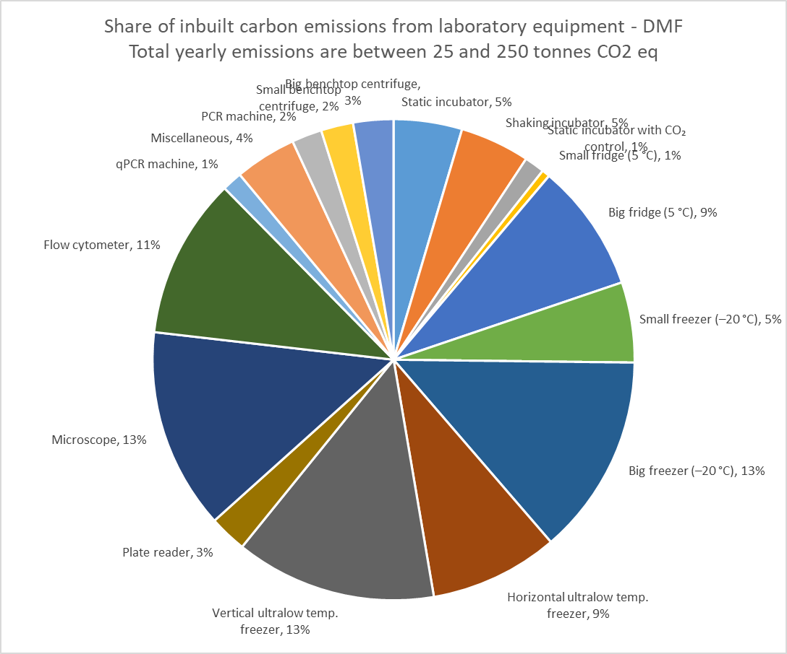

**Fig. 20 DMF share of inbuilt carbon emissions from laboratory equipment.**

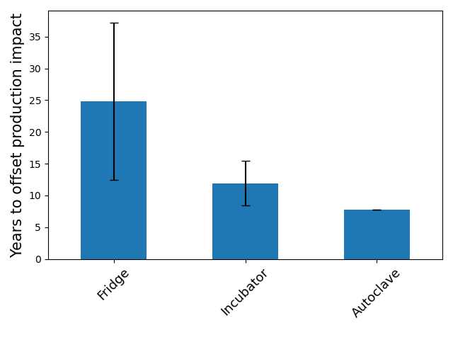

In addition, we tried to estimate the impact of services we outsource. From an exchange with DMF colleagues, we identified these as the mostly used services: DNA synthesis (short oligo synthesis, G-block synthesis), DNA sequencing (Sanger sequencing, Illumina sequencing, Oxford Nanopore sequencing), Metabolomics. Each service is offered by various providers, but we could not find on their websites detailed information about the environmental impact of these services. We thereby sought to estimate an order of magnitude independently: we compiled a list of the reagents and the necessary steps, and used that as a prompt for ChatGPT, asking a more conservative and a less conservative estimate. In parallel, we reached out to Microsynth, one of the most widely used service providers at DMF, which provided an internal estimate for some services.

Finally, we started estimating the frequency of usage of each service through crowdsourcing from the various DMF groups, but this effort is still ongoing.

Below is the table of estimated impacts per individual sample:

| **Technology** | **CO₂ emissions (chatGPT)** | **CO₂ emissions (Microsynth)** | **Water Use (chatGPT)** | **Land Use, Biodiversity loss, Waste (chatGPT)** |
| --- | --- | --- | --- | --- |
| DNA synthesis (20bp primer) | 50 – 150 g CO₂e | 150-170 g CO₂e | 10-50 L | petrochemical-derived reagents (plastics, solvents), energy production |
| Sanger sequencing | 60 - 150 g CO₂e | 10-15 g CO₂e | 5-10 L | petrochemical-derived reagents (plastic, fluorescent dyes, solvents), waste disposal |
| Oxford Nanopore sequencing | 70 - 200 g CO₂e | N.A. | 2-5 L | Petrochemical-derived reagents, some rare metals in flow cells; e-waste concerns |
| Illumina sequencing | 200 - 500 g CO₂e | 3.3 - 7.6 kg CO₂e/Gb* | 5-20 L | High reagent use, significant plastic and chemical waste |

* According to Microsynth estimates, transportation largely contributes to the emissions of this type of sequencing. Transportation: 2.25kg CO2 ; Packaging: 0.76 kg CO2 ; Shipment samples (4kg dry ice, Lausanne - Balgach): 0.2 - 0.8 kg CO2 ; Sequencing emissions per gigabase (Gb): 0.09 kg CO2eq (NovaSeq 6000) or 3.81 kg CO2eq (MiSeq).

Considering the very limited amount of data we could collect on this area, we decided to exclude it from the material provided to participants during the workshop. As an order of magnitude, the yearly impact of outsourced services in DMF is likely around 1-5 tonnes eqCO2.

The relevant CAP2037 objectives for this section are:

* Reduce energy consumption related to research by 20%, compared to 2019.
* Reduce volume of purchased laboratory consumables by 20%, compared to 2019.
* Reduce volume of purchased laboratory equipment by 40%, compared to 2019.

### Implemented measures for the optimization of laboratory equipment use and purchases (Biophore level)

DMF is tracking plastic consumption by recording any plastic item that is ordered from the Biophore shop.

DMF will soon also start testing the use of a pipette washing machine

### Implemented measures for laboratory sustainability (Unil level)

Green Labs is a task force at UNIL level which studies laboratory practices in order to identify solutions to increase laboratory sustainability. The Green Labs task force supports and encourages labs in UNIL to join the LEAF programme. LEAF (Laboratory Efficiency Assessment Framework) is a “tool to guide researchers and collaborators working in wetlabs in setting up research practices that make more optimal use of equipment and consumables” (from the [Green Labs website](https://www.unil.ch/unil/en/home/menuinst/universite/transition-ecologique/operations/green-labs.html)).

## Beyond Biophore’s direct influence: food

At Unil level, food accounts for 3% of total CO2eq consumption. However, it is worth noting that not all UNIL employees consume food prepared by cafeterias. In 2019, it was estimated that about one third of employees and students consumed meals prepared by cafeterias. This number is even lower in the 2023 assessment. In fact, the total volume of food produced by cafeterias is about two thirds the volume of 2019.

The decrease in volume is the main reason why the impact of food on the UNIL donut has decreased by 51% from 2019 to 2023. Although a vegetarian day per week has been introduced in the time frame between the two donut assessments, this did not have a significant reduction in emissions. It reduced the kg CO2eq/kg of food from 3.5 to 3.2.

To estimate the impact of food on CO2, we have used conversion factors provided to us by Cecilia Matasci, CCD. Another possibility is to consider the [Beelong](https://www.unil.ch/unil/en/home/menuinst/universite/transition-ecologique/operations/alimentation/audit-beelong.html) reports for different canteens. These reports contain detailed information on which foods have been used in each of the categories. Conversion factors for individual food items in the categories can be found, for example, on [ourworldindata.com](http://ourworldindata.com).

Some other useful links for reflection on food can be found here:

* Food waste in Switzerland (38% in households) <https://www.bafu.admin.ch/bafu/en/home/topics/economy-consumption/lebensmittelabfaelle.html>
* Greenhouse gas emissions of food across the supply chain <https://ourworldindata.org/food-choice-vs-eating-local>

The relevant CAP2037 objectives for this section are:

* Increase the proportion (by mass) of plant-based foods offered in cafeterias by at least 30% compared to 2019.
* Increase the proportion (by mass) of Swiss food products by at least 50% compared to 2019
* At least triple the amount (in mass) of products labelled bio, compared to 2019.

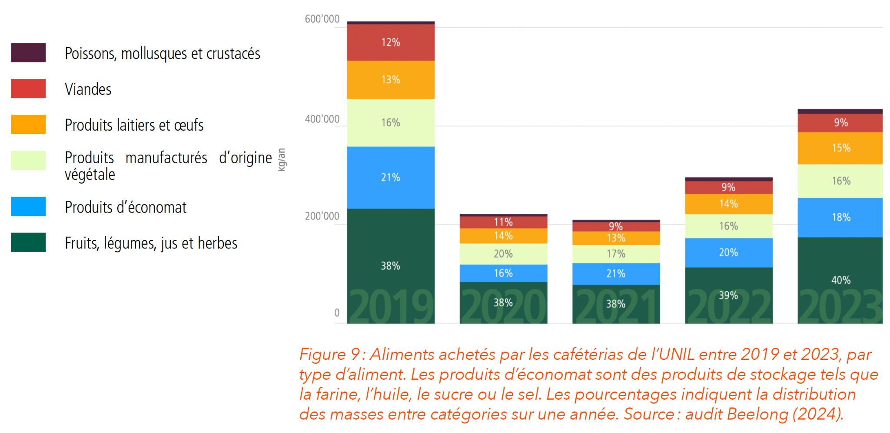

**Fig. 21 UNIL donut 2023: total food volume per category, from 2019 to 2023.**

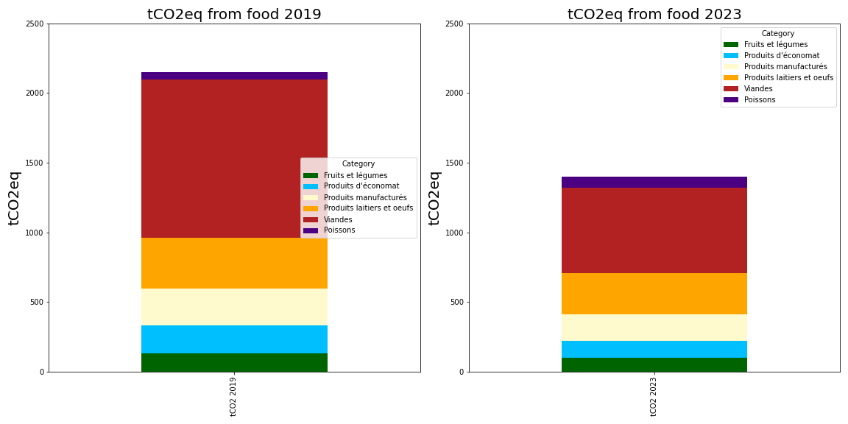

**Fig. 22 UNIL impact on greenhouse gas emissions from food, per category in 2019 and 2023.**

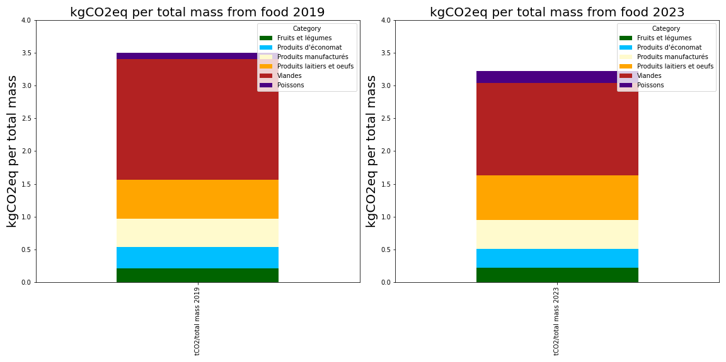

**Fig. 23 UNIL greenhouse gas emissions per kg of food, per category, in 2019 and 2023.**

## Beyond Biophore’s direct influence: commuting

At Unil level, commuting accounts for 15% of CO2eq production. Over the years, car usage has decreased in favor of “Plusieurs moyens” and “Vélo” (FIg. 24).

Although only a small fraction of UNIL employees use a car to commute, the impact on the total CO2eq emissions from commuting is due to cars by almost 56% (Fig. 25).

Different types of UNIL community members have different communing behaviors (Fig. 27). Moreover, higher use of bike could be due to the possibility of buying an electric bike (Fig. 28).

The relevant CAP2037 objectives for this section are:

* double the percentage of people walking or cycling to work, compared to 2019.
* half the percentage of people using personal motorised vehicles, compared to 2019.

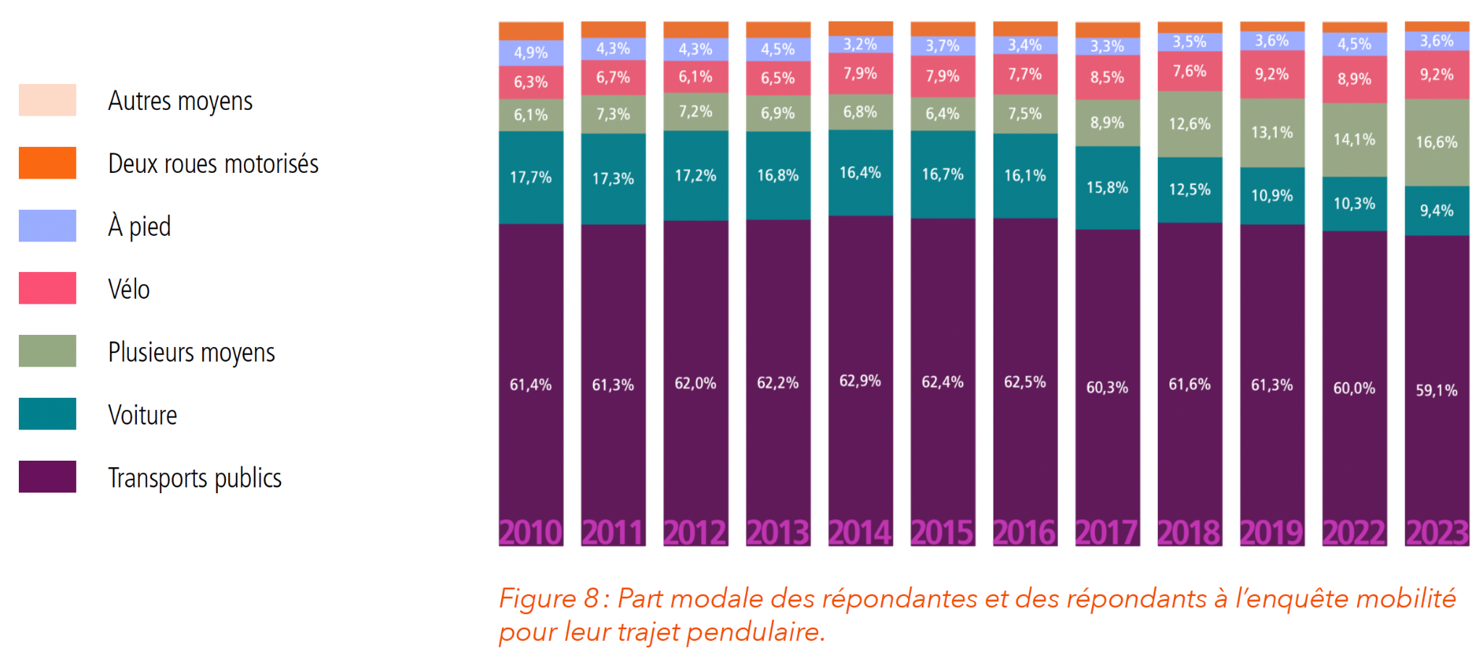

**Fig. 24 UNIL donut 2023: fraction of UNIL community using different means of transportation for their commute, from 2010 to 2023.**

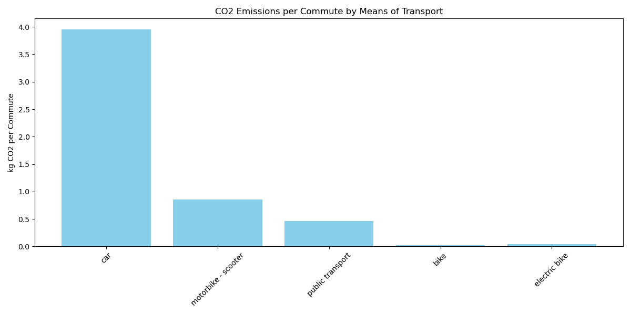

**Fig. 25 CO2 Emissions for a single commute to UNIL, for different means of transport.** Data on the average number of km for different means of transport was provided to us by Cecilia Matasci. The impact of each means of transport was taken from <https://www.suisseenergie.ch/programmes/calculateur-environnemental-transport/?pk_vid=e4ef18fb089eccbd17289962758e80eb> . Note that this program takes into account CO2 emissions from each stage in the means of transportation lifecycle.

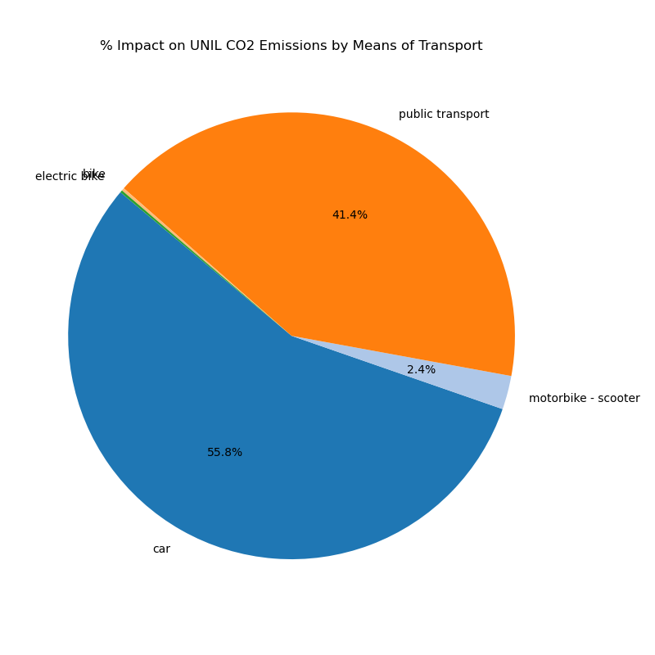

**Fig. 26 UNIL share of impact on total CO2 for different means of transport.** Note that “Plusieurs moyens” has been excluded from the calculation.

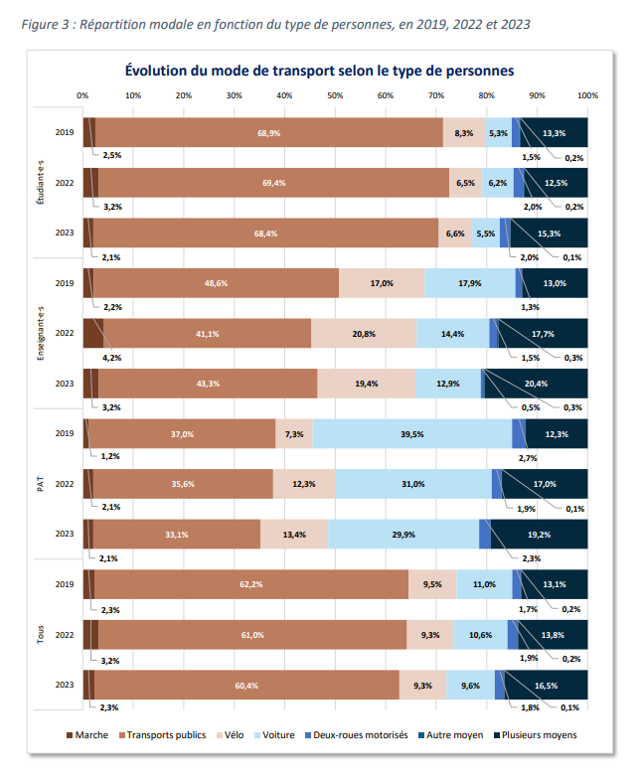

**Fig. 27 Fraction of UNIL community using different means of transportation for their commute, in 2019, 2022 and 2023, divided by type of community member.** Data from [Rapport Mobilité 2023](https://www.unil.ch/files/live/sites/unil/files/02-universite/0205-transition-ecologique/rapport-mobilite-campus-2023.pdf).

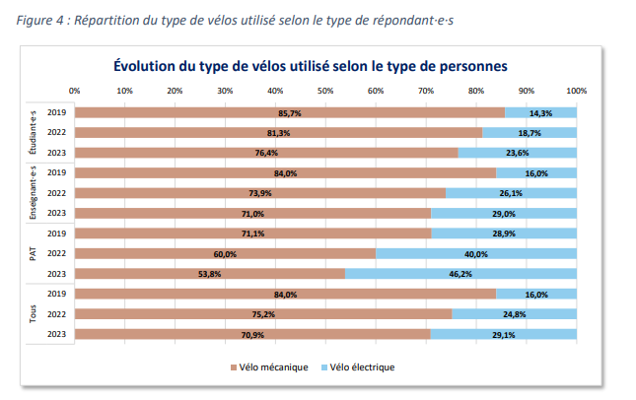

**Fig. 28 Fraction of UNIL community members having a mechanical or electric bike, in 2019, 2022 and 2023, divided by type of community member.** Data from [Rapport Mobilité 2023](https://www.unil.ch/files/live/sites/unil/files/02-universite/0205-transition-ecologique/rapport-mobilite-campus-2023.pdf).

# 